
A12
Sreenidhi Institute of Science and Technology
(An Autonomous Institution)
Code No: 3B511
B. TECH. III-Year I-Semester Examinations, December 2015 (Regular)
KINEMATICS OF MACHINERY (ME)

Time: 3 Hours Max. Marks: 70

Note: No additional answer sheets will be provided.

Part - A
Max.Marks:20

Answer all QUESTIONS. EACH QUESTION CARRIES 2 MARKS.
- What is partial and successful constrained motion?
- What is Coriolis component of acceleration? Give its magnitude and direction
- State the geometrical condition for correct steering.
- Draw the velocity, acceleration and jerk diagrams for the follower with SHM motion
- State the law of gearing
- What is self-locking and self energizing brake?
- Define inversion of a mechanism and list any two inversions of quadric cycle.
- What are copied and generated types of straight line motion mechanisms?
- Sketch the inverted gear train and find its train value
- How the pitch of a chain is calculated? Give its expression.
Part – B
Max.Marks:50
ANSWER ANY FIVE QUESTIONS. EACH QUESTION CARRIES 10 MARKS.

- Explain the inversions of a single slider crank mechanism with neat sketches
2. In a four –link mechanism, the crank AB rotates at 36r/s. The lengths of links are AB = 200 mm, BC = 400mm, CD = 450mm and AD = 600mm. AD is the fixed link. At the instant when AB is at right angles to AD, determine the velocity of
(i) The mid-point of the link BC
(ii) A point on the CD, 100 mm from the pin connecting the links CD and AD
(iii) The angular velocities of BC and CD.

3. What is Hooke’s joint? Derive an expression for the ratio of angular velocities of the shafts of a Hooke’s joint.

4. A cam with 30mm as minimum diameter is rotating at a uniform speed of 1200 rpm and has to give the following motion to a knife edged follower.
i) Follower to complete out word stroke of 25mm during 120⁰ of cam rotation with equal uniform acceleration and retardation.
ii) Follower to dwell for 60⁰ of cam rotation.
iii) Follower to return to its final position during 90⁰ of cam rotation with SHM.
iv) Follower to dwell for the remaining 90⁰ of cam rotation.
Draw the cam profile if the axis of the follower passes through the axis of the cam.

5. Two 20º full- depth involute spur gears having 30 and 48 teeth are in mesh. The pinion rotates at 800 rpm. The module is 4 mm. Find the sliding velocities at the engagement and at the disengagement of a pair of teeth and the contact ratio. If the interference is just avoided, find
(i) The addenda on the wheel and the pinion
(ii) The path of contact,
(iii) The maximum velocity of sliding at engagement and disengagement of a pair of
teeth, and
(iv) Contact ratio.

6. The smaller pulley of a flat belt drive has a radius of 220mm and rotates at 480 rpm. The angle of lap is 155⁰. The initial tension in the belt is 1.8kN and the coefficient of friction between the belt and the pulley is 0.3. Determine the power transmitted by the belt.

7. (a) Explain the Hart's straight line motion mechanism with a neat sketch

(b) Sketch and explain Pantograph give its applications .

8. A epicyclic gear train consists of five gears A, B, C, D and E as shown in figure. The wheels A and B as well as internal wheels C and D rotate independently about the axis O . The wheels E and F rotate on the pins fixed to arm a. All the wheels are of same module. The number of teeth on whells A,B,E and Fare 52, 56, 36 and 36 respectively. Determine the speed of C if
(i) The wheel D fixed and arm a rotates at 200 rpm clock wise.
(ii) The wheel D rotates at 20 rpm counter clock wise and the arm a rotates at
200 rpm clock wise.
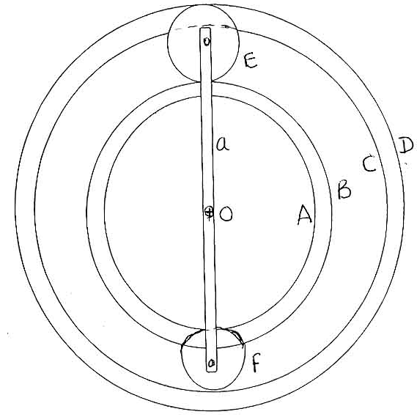

-- 00 -- 00 –

